Dear Colleague

**RE:** Primary School Competitions - Season 2019-2020

I am writing to provide details of the competition pathway and the rules for the Primary Schools’ Small Sided Competitions for this season.

Cheshire Schools FA is delighted to continue the working relationship with the School Games Competition programme and imbed Primary Schools’ Small Sided Competitions as part of the School Games programme for 2019-2020.

There are four different competition opportunities for a Primary School which are:

**Under 9s (Years 3&4):**

* Girls 5-a-side (Squads of 8) leading to CSFA Finals, 27/01/20: 12.30-4pm (8 teams - 1 per SGO area). NB This tournament is for Cheshire & Warrington Partnerships only.

**Under 11s (Years 5&6)**:

* Mixed 7-a-side Schools’ Cup for School Teams (Squads of 10) leading to CSFA Finals, 23/01/20: 12.30-4pm (20 teams - 2 per SGO area + 2 extra)
* Girls 7-a-side Schools’ Cup (Squads of 10) leading to CSFA Finals, 24/01/20: 12.30-4pm (20 teams - 2 per SGO area + 2 extra)
* Small Schools Mixed 7-a-side (Squads of 10) leading to CSFA Finals, 27/01/20: 12.30-4pm (9 teams - 1 per SGO area)

The competitions pathway is as follows:

Level 2 - Inter-School local District Schools FA/School Games Area Competition (delivered by the local competition provider - District Schools FA in partnership with the School Games Organisers), which may involve different knock-out rounds or league format.

Level 3 - Cheshire Schools FA County finals for certain competitions (a School Games branded event delivered by the Cheshire Schools FA with support from Cheshire County FA and Cheshire and Warrington School Sport Alliance).

Level 4 - Regional Finals (delivered by ESFA Northern Area Representative) for U11 competitions leading to a National Finals (delivered by ESFA).

All Primary Schools should be encouraged to enter the different competitions and must affiliated to Cheshire Schools FA through their local District Schools FA to be able to take part in this National competition structure.

It is vital that each District Schools Football Association/ lead Co-ordinator for the Primary School competitions links with their local School Games Organiser and vice versa for the co-ordination of the Level 2 Inter-School local competitions.

The national competition is sponsored by Danone. The Cheshire U11 tournaments are sponsored by MORNFLAKE and PROSEAL UK; the U9 Girls’ tournament by the Whitlow Family.

**The following provides the competition details and laws of the game.**

The Cheshire Schools FA County Finals (Level 3 event) are being held on –

Thursday 23 January 2020, 12.30 to 4.00pm at The Alexandra Soccer Centre, Crewe Road, Shavington, Crewe CW2 5AF for the **U11 Mixed 7-a-side Schools’ Cup for School Teams.**

Friday 24 January 2020, 12.30 to 4.00pm at The Alexandra Soccer Centre, Crewe Road, Shavington, Crewe CW2 5AF for the **U11 7-a-side Schools’ Cup for Girls**.

Monday 27 January 2020, 12.30 to 4.00pm at The Alexandra Soccer Centre, Crewe Road, Shavington, Crewe CW2 5AF for the **U11 mixed 7-a-side Small Schools Soccer Sevens** and **U9 5-a-side for Girls competition.**

**Competition Details:**

Please provide the full contact details of the Primary Schools progressing to the County Finals for each of the competitions (appendix A - a separate sheet for each School) and be returned by the closed date of **Monday 13 January 2020** to:

**Tracy Horth: tracycheshireschoolsfa@outlook.com**

Each Primary School attending the County Finals will receive a **confirmation** letter with full details of the event prior to the competition finals.

**Eligibility:**

Only boys/girls receiving full-time education in accordance with the Education Acts, on the roll of a school affiliated to the ESFA and to their Local Association.

To be eligible to enter the **Small Schools’** competition, the affiliated school must have fewer than 100 pupils on Roll in Key Stage Two, and not more than 30 pupils in Year 6. **Please Note:** Schools that qualify for the Small Schools Soccer Sevens may enter that competition OR the Schools’ Cup for School teams – **not both.**

These competitions are available to mixed teams except for the two Girls’ competitions. *Note: these competitions are to enhance the quality of girls’ football which is for single gender teams.*

**Team Requirements**

For Years 5&6 the competition will be **7-a-side** and squads may consist of a maximum of 10 players.

For Years 3&4 the competition will be **5-a-side** and squads may consist of a maximum of 8 players.

**Competition Format**

To ensure local Level 2 District Schools FA/School Games Area competitions are delivered there is flexibility in the competition format – the ideal is as follows –

Teams should play in ‘league format’, followed by a ‘knock-out’ section (if required depending on numbers) to determine a winner and runner up. This two section competition will ensure that every team will play more than one game.

Ideally two periods of equal time with the teams changing straight round at half time OR one way games depending on time & number of pitches available.

In the league section, a win will gain 3 points, a draw will gain 1 point and 0 points for a loss. Should teams share a qualifying position in the league the position shall be decided on goal difference. Should points and goal difference be equal the winners shall be the team scoring most goals. If this is equal, to determine the winning team, the position shall be decided by a play-off detailed below for knock-out section.

In the knock-out section if the scores are level at the end of normal time, play will continue for a period of six minutes, three minutes each way with the teams changing straight round at half time. If this fails to determine the winning team, the position will be decided by penalty kicks, taken in accordance with the regulation of FIFA, as published in the Laws of the Game.

**Other Match Regulations**

**Law 2** – U11’s (Year 5&6) size 4 and U9’s (year 3&4) size 3 Football shall be used. It should be safe and made of leather or other suitable material.

**Law 4 -** Players must wear shin guards and goalkeepers must wear a distinguishing playing top. Shin guards must be covered entirely by the socks.

Correct footwear must be worn for the surface of the pitch e.g. no metal studs on artificial grass pitches.

**Law 1 - Playing Area- Pitch set up**

Recommended size of pitch

**U11’s U9’s**

**Width**

Max. 40yards Max. 30yards

**Length**

Max. 60yards Max. 40yards

***Penalty Area -***

**U11’s U9’s**

**Length** 10 yards 9 yards

**Width** 18 yards 16 yards

***Halfway Line***

The field of play is divided into two halves by a halfway line. The centre mark is indicated at the midpoint of the halfway line.

***Goal Size***

The distance between the posts is 3.6m (12ft) and the distance between the lower edge of the cross bar and the ground is 1.88m (6ft).

**Warning – Goalpost Safety**

Several serious injuries and fatalities have occurred in recent years as a result of unsafe or incorrect use of goalposts. Safety is always of paramount importance and everyone in football must play their part to prevent similar incidents occurring in the future. For safety reasons goalposts of any size (including those which are portable and not installed permanently at a pitch or practice field) must always be anchored securely to the ground or have a weighted back bar to prevent them from toppling forward.

The Football Association Laws for Mini-Soccer is applied to the Primary Schools competitions. An overview is provided below.

* **Free kicks** - all free-kicks are direct. For all free kicks opponents must be 4.5m (5 yards) from the ball.
* **Throw-ins** - encourage both feet must be in contact with the ground and correct technique. A goal cannot be scored direct from a throw-in.
* **Back Passes** – a free kick is awarded to the opposing team if the goalkeeper touches the ball with his/her hands after it has been deliberately kicked to him/her by a team mate.
* **Substitutions** - is roll on roll off at a stoppage in play with the referee being informed.
* **Goalkeepers** - Goalkeepers are allowed to come out of and players are allowed to go into the penalty area.
* **Goal Kick** – **(Retreat Line)** opponents must retreat to their own half until the ball is in play. The defending team does not have to wait for the opposition to retreat and has the option to restart the game before should they choose to (please see attached diagram below).
* There is NO offside.
* A goal cannot be scored direct from a goalkeeper restart or a kick off.
* Players must not wear any Jewellery or ‘non-sport’ spectacles i.e. NO glasses

The decisions of the referee regarding facts connected with play are final.

**The Retreat Line: Diagram**

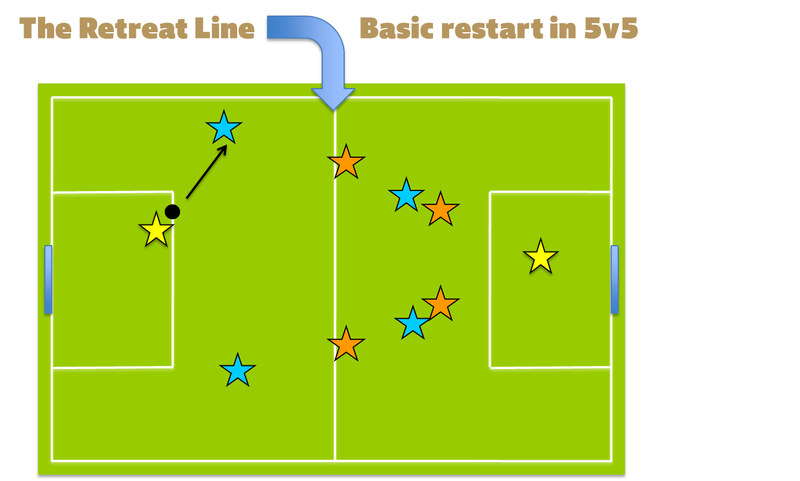



**CONTACT DETAILS**

Cheshire Schools FA Administrator: Tracy Horth – [tracycheshireschoolsfa@outlook.com](mailto:tracycheshireschoolsfa@outlook.com)  
Cheshire Schools FA Primary Secretary: Tom Freeman – [tom.freeman@delamere.cheshire.sch.uk](mailto:tom.freeman@delamere.cheshire.sch.uk)  
Cheshire Schools FA Secretary: John Clark – [j.r.clark@talktalk.net](mailto:j.r.clark@talktalk.net); 01260 252076; 07436 114577

**APPENDIX A**

**Primary School Finals Contact Details Form – Please complete all sections**

DSFA/SGA:

Date of Association/Area Competition:

Competition (please tick):

U11 7-a-side Schools’ Cup for School Teams □

U11 7-a-side Schools’ Cup for Girls □

U11 7-a-side Small Schools’ Cup □

U9 5-a-side Schools’ Cup for Girls □

Primary School Name:

Primary School Contact Name:

School Address:

Contact e-mail address:

School Contact number:

Please return to:

**TRACY HORTH: tracycheshireschoolsfa@outlook.com**

Closing date is **Monday 13 January 2020**